WPD5 7.5 – 9.36 GHz,2 rings
Table 5. Trace width and length for WPD5
Z0(90 degree) | W(mil) | L(mil)
59.5 | 30.86 | 2.0997e+02
84.03 | 14.4 | 2.1499e+02
50 | 42 | **
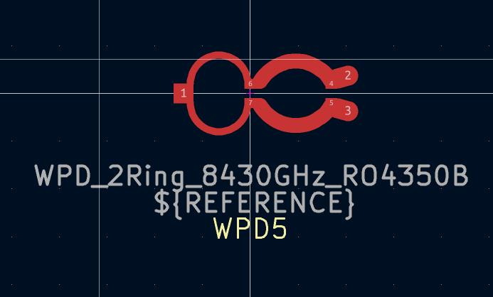
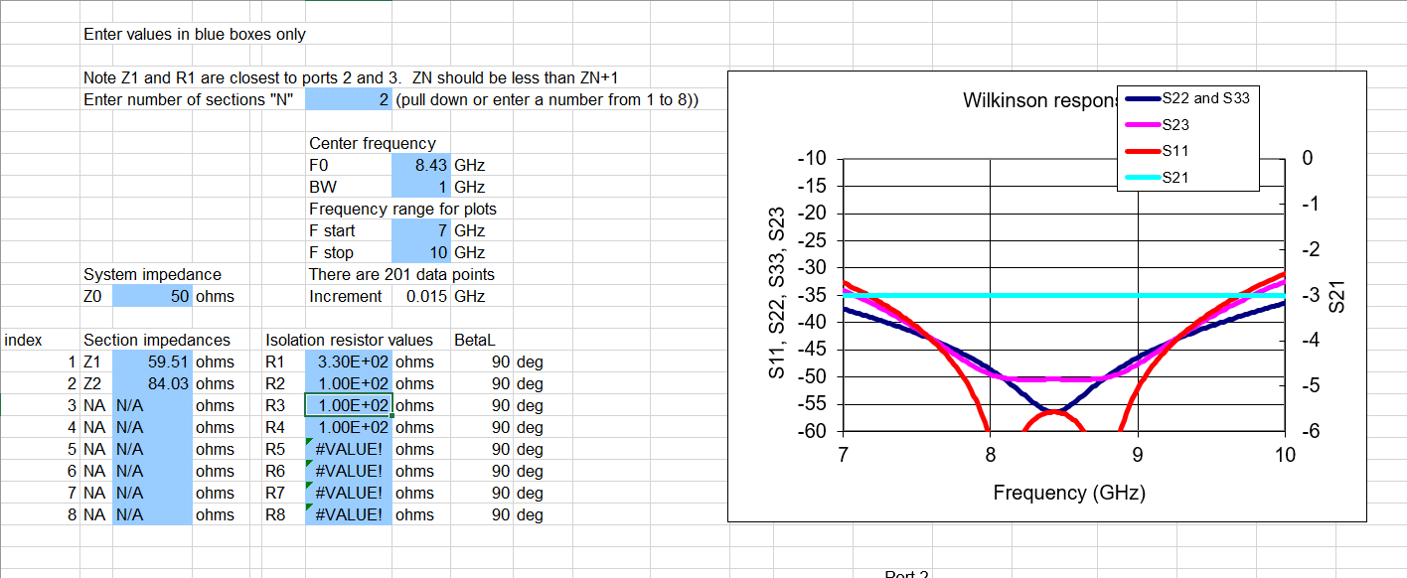
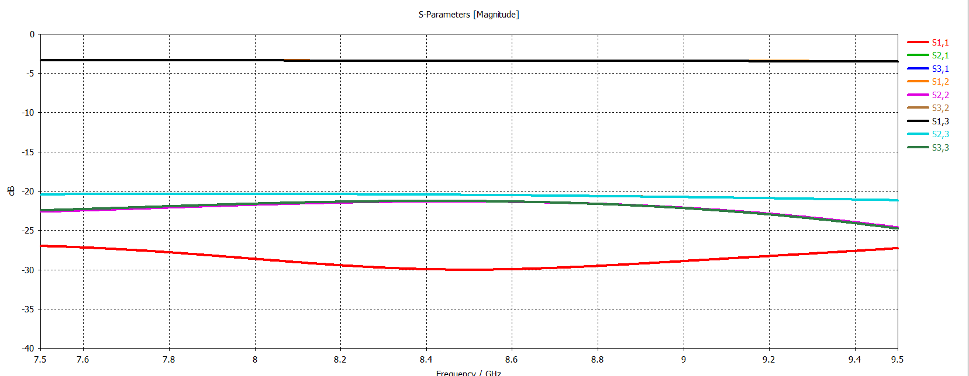

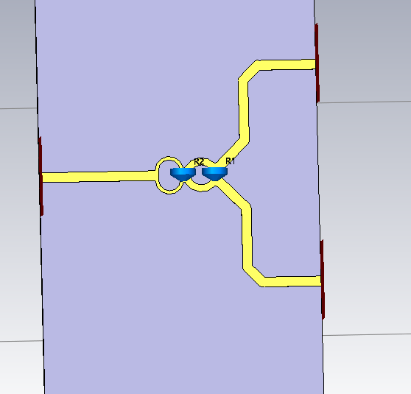
Figure 1.R1=330 Ohm R2 = 100 Ohm

